We will use Github to do this; our process follows.  
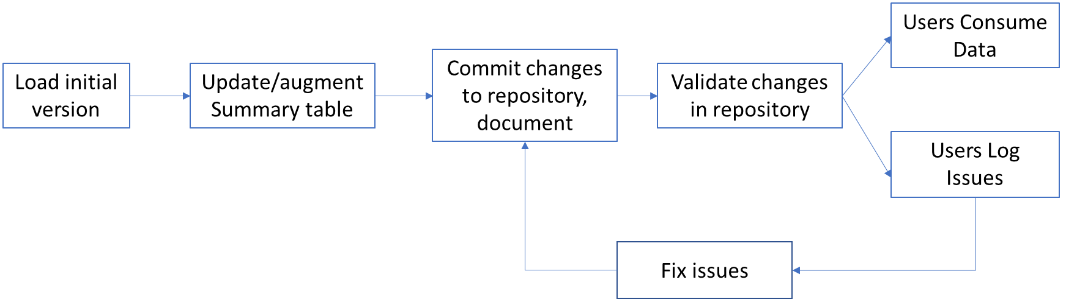

Figure . Proces for updating summary tables in github

This process contains four steps

* **Load Initial version:** we will start our process by loading the as-published version of the summary table into github and designating it as the master table. From this point forward, we will use github to track and document any changes to the master table – correcting specific values, adding columns, or systematically modifying existing columns.
* **Update summary table:** after loading the table, we will develop code to implement the changes that we have identified in our requirements gathering session with NEEA and the council. Our approach will be to use the same language that NEEA’s contractor originally wrote the summary tables in (R, Python, SQL, etc.).
* **Commit changes:** after updating the table using code, we will commit this change to the github repository. Upon committing the change, we will also log a detailed description of the changes to github. Similarly, we will use github to manage and document any subsequent changes to the summary tables.
* **Validate changes:** we will run a QC process, described above, to ensure that the updated changes are correct. Once correct, we will update the master table, meaning that any user that consumes this data will be using the most recent, QCed version of the data

In addition to managing the update process, github provides two valuable features to NEEA and the broader CBSA user base.

* **Issues logging.** While we do not expect to introduce new analytical errors to the CBSA summary tables, we acknowledge that users could identify new issues in the future, such missing columns or incorrectly coded columns. Any user can log an issue directly in the github platform – NEEA can use this issue log to determine, at its discretion, what issues, to address in future releases of the summary table. In addition, this documentation of issues is public – the CBSA user base will be able to use the issues log to determine if other users have encountered similar problems in the past and share best practices.
* **Notifications.** Users can also subscribe to the repository so that they can automatically be notified of changes to the master version of the summary table in the future.